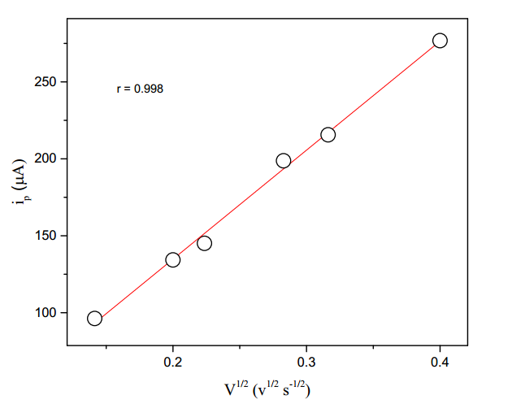

Fig.2. Plot of first peak current (ip) versus square root of sweep rates for the electrolytic

reduction of (E)-1-(furan-2-yl)-3-phenylprop-2-ene-1-ones (10 mM) in tetra butyl ammonium

tetra fluoroborate.

Solvent = acetonitrile



Fig. Plot of first peak current (ip) versus square root of sweep rates for the electrolytic

reduction of (E)-1-(furan-2-yl)-3-phenylprop-2-ene-1-ones (10 mM) in tetra butyl ammonium

tetra fluoroborate.